**Toxocariasis**

**Toxocariasis** is an illness of humans & animals caused by a larvae (immature worms) of either the dog round worm (*[Toxocara](http://en.wikipedia.org/wiki/Toxocara_canis)* [*canis*](http://en.wikipedia.org/wiki/Toxocara_canis)) or the cat round worm (*[Toxocara](http://en.wikipedia.org/wiki/Toxocara_cati)* [*cati*](http://en.wikipedia.org/wiki/Toxocara_cati)).

Depending on their : location, degree of esoinophilia, eye and pulmonary signs, There are three main syndromes:

1- [*visceral larva migrans*](http://en.wikipedia.org/wiki/Visceral_larva_migrans) (VLM), which encompasses diseases associated with major organs .

2- *covert toxocariasis*, which is a milder version of VLM .

*3- ocular larva migrans* (OLM), in which pathological effects on the host are restricted to the eye and the [optic nerve](http://en.wikipedia.org/wiki/Optic_nerve).

This [zoonotic](http://en.wikipedia.org/wiki/Zoonotic), [helminthic](http://en.wikipedia.org/wiki/Helminth) infection is a major cause of blindness and may provoke [rheumatic](http://en.wikipedia.org/wiki/Rheumatic), [neurologic](http://en.wikipedia.org/wiki/Neurologic), or [asthmatic](http://en.wikipedia.org/wiki/Asthmatic) symptoms .

**Transmission**

Humans & animals normally become infected by:

1- ingestion of embryonated eggs (containing a fully developed [larva](http://en.wikipedia.org/wiki/Larva), L2) from contaminated sources with infected feces : (soil, fresh or un washed vegetables) Humans can also contaminate foods by not washing their hands before eating .

Flies can act as mechanical vectors for Toxocara , flies that feed on feces can spread *Toxocara* eggs to surfaces or foods.

Young children who put contaminated objects in their mouths or eat dirt ([pica](http://en.wikipedia.org/wiki/Pica_(disorder))) are at risk of developing symptoms .

2- by eating [paratenic](http://en.wikipedia.org/wiki/Paratenic) hosts (for human : improperly cooked [paratenic](http://en.wikipedia.org/wiki/Paratenic) hosts ) .

There are many 'accidental' or [paratenic](http://en.wikipedia.org/wiki/Paratenic) hosts including humans, birds, pigs, rodents, goats, monkeys, sheep and rabbits , In paratenic hosts the larvae never mature and remain at the encysted L2 stage , eating undercooked rabbit, chicken, or sheep can lead to infection; encysted larvae in the meat become reactivated and migrate through a human host, causing toxocariasis.

Dogs are the reservoir for *Toxocara canis*, but puppies pose the greatest risk of spreading the infection to humans.

Infection in adult dogs is aquired by eating infected eggs through contaminated food , ingestion of a paratenic host , infection in adults is characterized by encysted second stage larvae , these larvae can become reactivated in pregnant females and cross the placental barrier to infect the pups, Vertical transmission can also occur through breast milk.

Infectious mothers, and puppies under five weeks old, pass eggs in their feces .

Cats can acquire a *T. cati*infection by several ways: ingestion of eggs , ingestion of a paratenic host, or by larvae through the milk.

As with *T. canis*, encysted second stage larvae in pregnant or lactating cats become reactivated, but vertical transmission can occur through breast feeding only .  If the larvae are passed out in the kitten's feces before they can mature, they can infect the mother when she licks her kitten . kittens are more of a risk for human infection than adult cats .The defecation habits of cats reduce the chances of human infection with *T. cati.*

|  |  |  |  |  |
| --- | --- | --- | --- | --- |
|  | **Eggs, through Ingestion** | **Larvae, through the milk** | **Larvae, across the placenta** | **Larvae, by ingestion of paratenic host** |
| ***T. cati*** | X | X |  | X |
| ***T. canis*** | X | X | X | X |

**Incubation period**

Both *Toxocara canis* and *Toxocara cati* eggs require a several week incubation period outside of a host before becoming infective, so fresh eggs cannot cause toxocariasis , the incubation period depends on temperature and humidity . Under ideal summer conditions, eggs can mature to the infective stage (second (and possibly third) stage larva in the egg ) after two weeks outside of a host . *Toxocara* eggs can remain infectious for years, as they are very resistant to the effects of chemicals, as well as changes in temperature.

**Life cycle**

Infection with *Toxocara* can become through the ingestion of embryonated eggs or by transmission of the 2nd larvae from a mother to her offspring & can also occur by ingestion of infected accidental hosts, such as earthworms, cockroaches, rodents, rabbits, chickens, or sheep.

Eggs hatch as second stage larvae in the intestines of the cat or dog host . Larvae enter the blood stream and migrate to the lungs, where they are coughed up and swallowed. The larvae mature into adults within the small intestine of a cat or dog, where mating and egg laying occurs . Eggs are passed in the feces and only become infective after several weeks outside of a host. During this incubation period, molting from first to second (and possibly third) stage larva takes place within the egg .

In most adult dogs and cats, the full life cycle does not occur, but instead second stage larvae encyst after a period of migration through the body. Reactivation of the larvae is common only in pregnant or lactating cats and dogs. The full life cycle usually only occurs in these females and their offspring .

Second stage larvae will also hatch in the small intestine of an accidental host, such as a human, after ingestion of infective eggs. The larvae will then migrate through the organs and tissues of the accidental host, most commonly the lungs, liver, eyes, and brain. Since L2 larvae cannot mature in accidental hosts, after this period of migration, *Toxocara* larvae will encyst as second stage larvae.

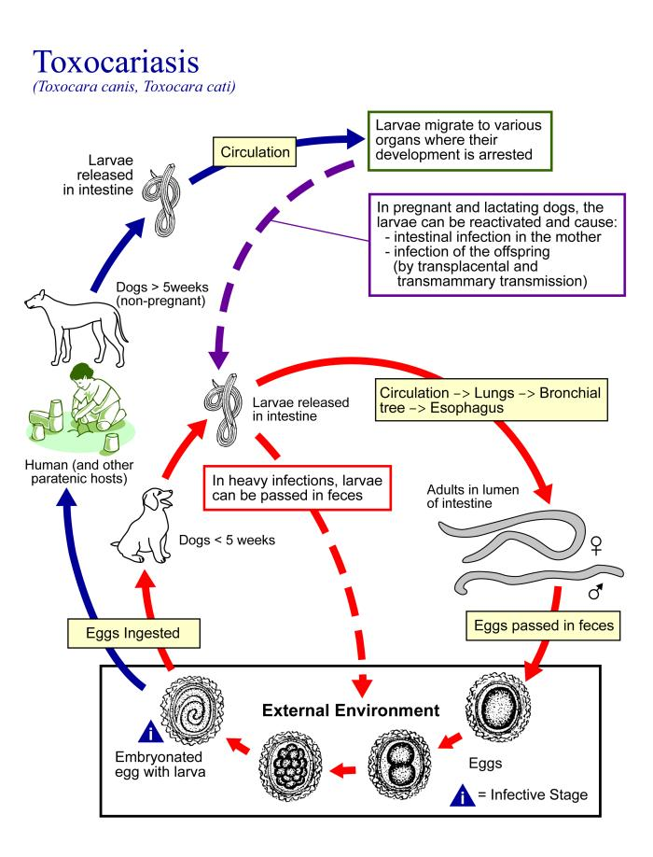**Clinical presentation**

Physiological reactions to *Toxocara* infection depend on the host’s immune response and the parasitic load. Most cases of *Toxocara* infection are asymptomatic, especially in adults.When symptoms do occur, they are the result of migration of second stage *Toxocara* larvae through the body.

Covert toxocariasis is the least serious of the three syndromes and is believed to be due to chronic exposure. Signs and symptoms of covert toxocariasis are coughing, fever, abdominal pain, headaches, and changes in behavior and ability to sleep. Upon medical examination, wheezing, [hepatomegaly](http://en.wikipedia.org/wiki/Hepatomegaly), and [lymphadenitis](http://en.wikipedia.org/wiki/Lymphadenitis) are often noted.

High parasitic loads or repeated infection can lead to visceral larva migrans (VLM). VLM is primarily diagnosed in young children, because they are more prone to exposure and ingestion of infective eggs.*Toxocara* infection commonly resolves itself within weeks, but chronic [eosinophilia](http://en.wikipedia.org/wiki/Eosinophilia) may result. In VLM, larvae migration incites inflammation of internal organs and sometimes the central nervous system.Symptoms depend on the organ(s) affected. Patients can present with pallor, fatigue, weight loss, anorexia, fever, headache, rash, cough, asthma, chest tightness, increased irritability, abdominal pain, nausea, and vomiting. Sometimes the subcutaneous migration tracks of the larvae can be seen

light *Toxocara* burden is thought to induce a low immune response, allowing a larva to enter the host’s eye .OLM often occurs in just one eye and from a single larva migrating into and encysting within the orbit. Loss of vision occurs over days or weeks , Other signs and symptoms are red eye, white pupil, fixed pupil, retinal fibrosis, retinal detachment, inflammation of the eye tissues

**prevention**

* Since pregnant or lactating dogs and cats and their offspring have the highest, active parasitic load, these animals should be placed on a deworming program .
* Pet feces should be picked up and disposed of or buried, as they may contain *Toxocara* eggs .
* Hand washing before eating and after playing with pets, as well as after handling dirt will reduce the chances of ingesting *Toxocara* eggs .
* Washing all fruits and vegetables, keeping pets out of gardens and thoroughly cooking meats can also prevent transmission .
* Finally, teaching children not to place non food items, especially dirt, in their mouths will reduce the chances of infection .

**Diagnos**i**s**

In humans it is not depending on fecal exam , so serological test like ELISA or PCR will be depended & biopsy from infected organs . while diagnosis in dogs & cats in laboratory is usually by fecal flotation , direct smear (usually for mothers & their offsprings ) & by other serological tests espically in older dogs & cats .

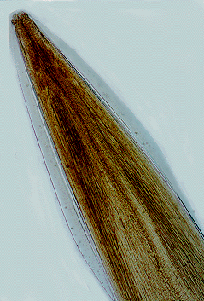 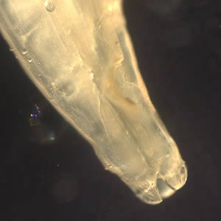

Close-up of the anterior end of *Toxocara* *canis*.

Close-up of the anterior end of *Toxocara* sp., showing the three lips characteristic of ascarid worms.

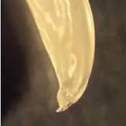 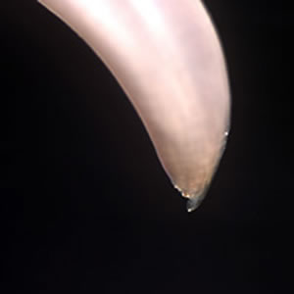

Close-up of the posterior end of *T. cati*, showing a prominent point at the end of the “tail.”

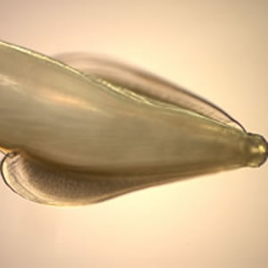 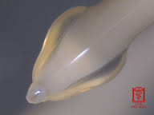

Side view showing the broad, arrow-shaped alae with striations, characteristic of *T. cati*.

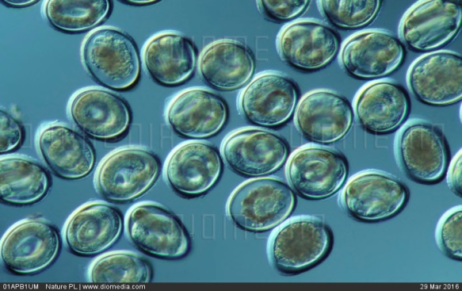 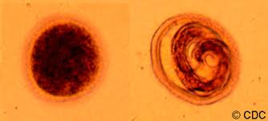



embryonated egg contain L2

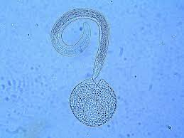

L2 is hatching from egg

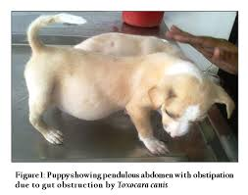 

Dog showing pendulous abdomin due to gut obstruction by *T. canis*

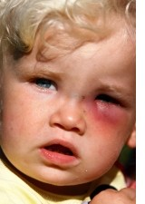 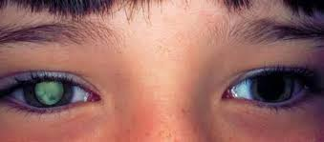

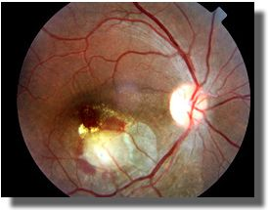 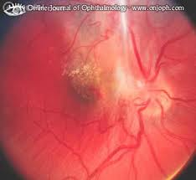

Red eye ,white pupil ,retinogranuloma of OLM

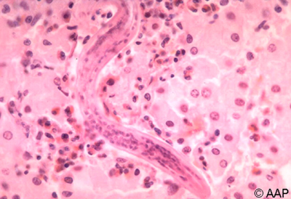

L2 in liver biopsy

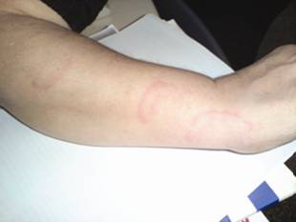

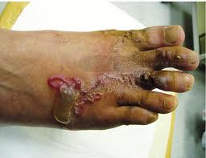 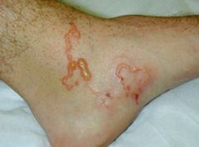

Subcutaneous tracks of VLM